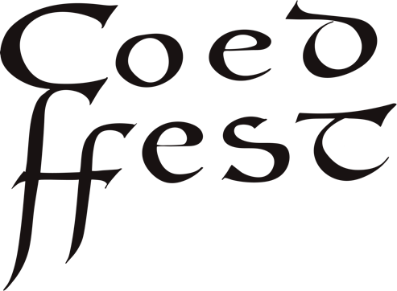

Sponsor partnerships

Coed Ffest is an eco-conscious, mid-summer festival celebrating land, locally grown food, creativity and well-being at Coed - an events and retreat space located just outside of St. Hilary in the Vale of Glamorgan.

Our vision is to create a space for connection, healing and well-being focused around conscious and sustainable living.

As a not-for-profit, small-scale festival, we are seeking local businesses who share our vision and who would like to sponsor the growth and success of our festival.

Any profits from the festival to support regenerative and environmental projects. Our current charities that we support are Ediculture, a charitable trust that promotes local food and foraging, and Trees of Hope Zimbabwe, a charitable tree nursery to support the regeneration of the natural eco-system in Zimbabwe.

 | Coed Ffest benefit | Business benefit | Cost
Package 1 | Covers a volunteers food costs. | Logo on Coed Ffest website. | £50
Package 2 | Covers the cost of a workshop leader. | Logo on Coed ffest website, plus one ticket at family and friends rate. | £150
Package 3 | Covers the cost of Oasis choir to perform. | Logo on Coed Ffest website and program, 2 tickets at family and friends rate. | £350
Package 4 | Covers the cost of a headline musician to perform. | Logo on Coed Ffest website and programme, two free Coed Ffest tickets, including meal tickets. | £500
Package 5 | Covers the cost of a headline full live band. | Logo on Coed Ffest website and programme. two free Coed Ffest tickets, including meal ticket and accommodation. | £750
Package 6 | Covers the cost of the hire of our big marquee. | Logo on Coed Ffest website and programme. Four free Coed Ffest tickets, including meal ticket and accommodation in one of our eco pods. | £1250

We are also open to discussing bespoke packages. If you would like to find out more, please contact

ediculture@gmail.com

07507578885
Coed Hills
St Hilary
Vale of Glamorgan
CF717DP

